

Name : Adil Khan
Roll No : 2330-0030
Dept: BS AI
Subject: Data Base system

Question NO 1:

CREATE DATABASE Library;
USE Library;
CREATE TABLE Books (
BookID INT,
Title VARCHAR(50),
Author VARCHAR(50),
Price INT
);

CREATE TABLE Borrowers (
BorrowID INT,
StudentName VARCHAR(50),
BookID INT,
BorrowDate DATE
);

INSERT INTO Books VALUES
(1, 'Database Systems', 'Korth', 500),
(2, 'AI Basics', 'Stuart', 700),
(3, 'Web Development', 'Jonas', 450),
(4, 'Data Science', 'Python', 800),
(5, 'Networks', 'Tanenbaum', 600);

INSERT INTO Borrowers VALUES
(101, 'Ali', 1, '2024-01-10'),
(102, 'Sara', 2, '2024-01-12'),
(103, 'Ahmed', 1, '2024-02-01'),
(104, 'Hina', 4, '2024-02-05'),
(105, 'Usman', 3, '2024-02-10');

Task no 01:
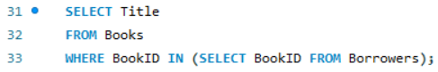
Output:
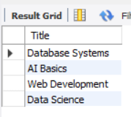

Task no 02:
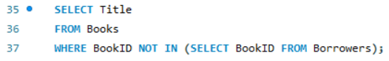
Output:
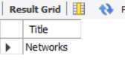

Task no 03:
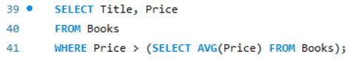
Output:
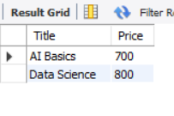
Task no 04:
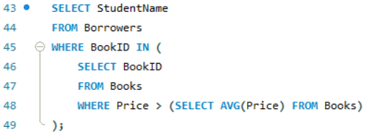
Output:
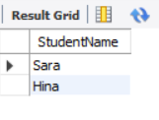

Task no 05:
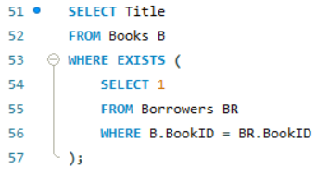
Output:
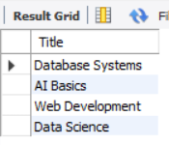

Task no 06:
Output:
